Sahil Saini Salaria

Reg no 180905048

Roll No. 11 C

Q1

#include <stdio.h>
#include <string.h>
#include <mpi.h>

int main(int argc, char *argv[])
{
int rank, size, n;
MPI_Status status;
MPI_Init(&argc, &argv);
MPI_Comm_size(MPI_COMM_WORLD, &size);
MPI_Comm_rank(MPI_COMM_WORLD, &rank);

if (rank == 0)
{
char a[25];

fprintf(stdout, "Enter the Word : \n");
fflush(stdout);
scanf("%s", a);

n = strlen(a);

MPI_Ssend(&n, 1, MPI_INT, 1, 0, MPI_COMM_WORLD);
printf("Sent\n");
MPI_Ssend(a, n+1, MPI_CHAR, 1, 1, MPI_COMM_WORLD);
fprintf(stdout, "Process %d sent: %s\n", rank, a);
fflush(stdout);
MPI_Recv(a, n+1, MPI_CHAR, 1, 2, MPI_COMM_WORLD, &status);
fprintf(stdout, "Process %d recieved: %s\n", rank, a);
fflush(stdout);
}
else if (rank == 1)
{
char b[25];

MPI_Recv(&n, 1, MPI_INT, 0, 0, MPI_COMM_WORLD, &status);
printf("Got\n");
MPI_Recv(b, n+1, MPI_CHAR, 0, 1, MPI_COMM_WORLD, &status);
fprintf(stdout, "Process %d recieved: %s\n", rank, b);
fflush(stdout);

for (int i = 0; i < n; i++)
{
if (b[i] >= 'a' && b[i] <= 'z')
{
b[i] = b[i] - 32;
}
else
{
b[i] = b[i] + 32;
}
}
MPI_Ssend(b, n+1, MPI_CHAR, 0, 2, MPI_COMM_WORLD);
fprintf(stdout, "Process %d sent: %s\n", rank, b);
fflush(stdout);
}
MPI_Finalize();
return 0;
}
mpicc prog1.c -lm -o prog1 && mpirun -np 4 ./prog1
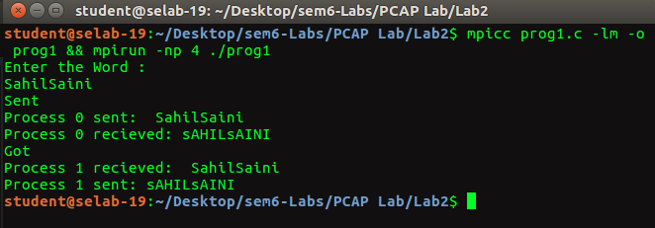
Q2

#include <mpi.h>
#include <stdio.h>
#include <math.h>
#include <string.h>

int main(int argc, char *argv[])
{
int rank, size;

MPI_Init(&argc, &argv);
MPI_Comm_rank(MPI_COMM_WORLD, &rank);
MPI_Comm_size(MPI_COMM_WORLD, &size);

MPI_Status status;
int ele;

if (rank == 0)
{
printf("Enter number in master:\n");
scanf("%d",&ele);

printf("Number sent from the master!\n");
for (int i = 1; i < size; i++)
{
MPI_Send(&ele, 1, MPI_INT, i, i, MPI_COMM_WORLD);
}
}
else
{
int ele2;
MPI_Recv(&ele2, 1, MPI_INT, 0, rank, MPI_COMM_WORLD, &status);
printf("Rank %d\t Number:%d \n", rank, ele2);
}

MPI_Finalize();

return 0;
}

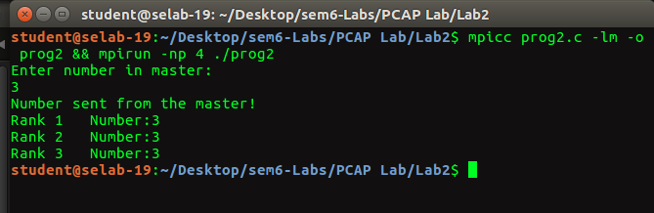
// mpicc prog2.c -lm -o prog2 && mpirun -np 4 ./prog2

Q3

#include <stdio.h>
#include <mpi.h>

int main(int argc, char *argv[])
{
int rank, size;

MPI_Init(&argc, &argv);
MPI_Comm_rank(MPI_COMM_WORLD, &rank);
MPI_Comm_size(MPI_COMM_WORLD, &size);

MPI_Status status;

char buff[100];
int n = 100l;
MPI_Buffer_attach(buff, n);
if (rank == 0)
{
int arr[100];

printf("Enter %d numbers:\n", size);
scanf("%d", &arr[0]);
printf("Rank 0: Square of %d is :%d\n", arr[0], arr[0] * arr[0]);

for (int i = 1; i < size; i++)
{
scanf("%d", &arr[i]);
MPI_Bsend(&arr[i], 1, MPI_INT, i, i, MPI_COMM_WORLD);
}
}
else
{
int ele;
MPI_Recv(&ele, 1, MPI_INT, 0, rank, MPI_COMM_WORLD, &status);

if (rank % 2 == 0)
printf("Rank %d: Square of %d is :%d\n", rank, ele, ele*ele);
else
printf("Rank %d: Cube of %d is :%d\n", rank, ele,ele* ele* ele);
}

MPI_Buffer_detach(buff, &n);
MPI_Finalize();

return 0;
}

// mpicc prog3.c -lm -o prog3 && mpirun -np 4 ./prog3

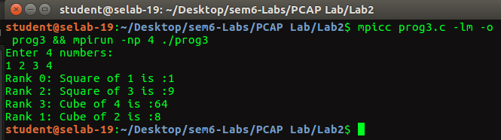

Q4

#include <stdio.h>
#include <mpi.h>

int main(int argc, char *argv[])
{
int rank, size;

MPI_Init(&argc, &argv);
MPI_Comm_rank(MPI_COMM_WORLD, &rank);
MPI_Comm_size(MPI_COMM_WORLD, &size);

MPI_Status status;

if (rank == 0)
{
int ele;
printf("Enter a value:\n");
scanf("%d", &ele);

MPI_Send(&ele, 1, MPI_INT, 1, 1, MPI_COMM_WORLD);

MPI_Recv(&ele, 1, MPI_INT, size-1, 1, MPI_COMM_WORLD, &status);
printf("Rank 0. Recived value %d \n", ele);

}
else
{
int ele;
MPI_Recv(&ele, 1, MPI_INT, rank - 1, 1, MPI_COMM_WORLD, &status);
printf("Rank %d. Recived value %d \n", rank, ele);
ele += 1;
if (rank < size - 1)
{
MPI_Send(&ele, 1, MPI_INT, rank + 1, 1, MPI_COMM_WORLD);
}
else
MPI_Send(&ele, 1, MPI_INT, 0, 1, MPI_COMM_WORLD);
}

MPI_Finalize();

return 0;
}

// mpicc prog4.c -lm -o prog4 && mpirun -np 4 ./prog4

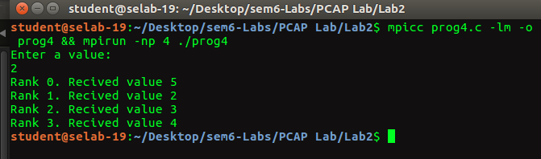

////////////////////////////////////////////////////////////////////////////////////////////////////////////////////////////////////////////////

Additional:

Additional 1.

#include <stdio.h>
#include <mpi.h>

int isPrime(int num)
{
if(num==1)
return 0;

for (int i = 2; i*i <= num; i++)
{
if(num%i==0)
return 0;
}
return 1;
}

int main(int argc, char *argv[])
{
int rank, size;

MPI_Init(&argc, &argv);
MPI_Comm_rank(MPI_COMM_WORLD, &rank);
MPI_Comm_size(MPI_COMM_WORLD, &size);

MPI_Status status;

char buff[100];
int n = 100l;
if (rank == 0)
{
int arr[100];

printf("Enter %d numbers:\n", size);
scanf("%d", &arr[0]);

if (isPrime(arr[0]))
{
printf("Rank %d. Number: %d Is Prime\n",rank,arr[0]);
}
else
printf("Rank %d. Number: %d Is Not Prime\n",rank,arr[0]);

for (int i = 1; i < size; i++)
{
scanf("%d", &arr[i]);
MPI_Send(&arr[i], 1, MPI_INT, i, i, MPI_COMM_WORLD);
}
}
else
{
int ele;
MPI_Recv(&ele, 1, MPI_INT, 0, rank, MPI_COMM_WORLD, &status);
if (isPrime(ele))
{
printf("Rank %d. Number: %d Is Prime\n",rank,ele);
}
else
printf("Rank %d. Number: %d Is Not Prime\n",rank,ele);

}

MPI_Finalize();

return 0;
}

// mpicc Additional1.c -lm -o Additional1 && mpirun -np 4 ./Additional1

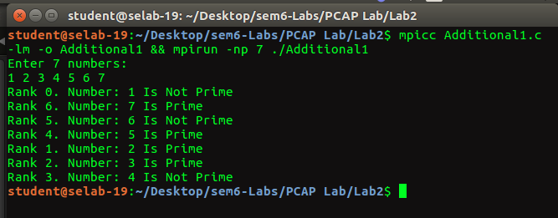

Additional 2.

#include <stdio.h>
#include<mpi.h>

int main(int argc, char *argv[])
{
int rank,size;
MPI_Init(&argc,&argv);
MPI_Comm_rank(MPI_COMM_WORLD,&rank);
MPI_Comm_size(MPI_COMM_WORLD,&size);

MPI_Status status;

if(rank==0)
{
int n;
long long int sum=0;
printf("Here n is: %d\n",size);

printf("Rank 0 finds: 1\n");
sum=sum+1;

for (int i = 1; i < size; i++)
{
int ele;
MPI_Recv(&ele,1,MPI_INT,MPI_ANY_SOURCE,1,MPI_COMM_WORLD,&status);
sum+=ele;
}
printf("Total = %lld\n",sum );

}
else
{
long long int sumTemp=1;
printf("Rank %d finds :1",rank);
if(rank%2==1)
{

for (int i = 2; i <=rank+1; i++)
{
sumTemp+=i;
printf("+%d",i);
}
}
else{

for (int i = 2; i <=rank+1; i++)
{
sumTemp*=i;
printf("*%d",i);

}
}

printf(" = %lld\n",sumTemp );
MPI_Send(&sumTemp,1,MPI_INT,0,1,MPI_COMM_WORLD);

}

MPI_Finalize();
return 0;

// mpicc Additional2.c -lm -o Additional2 && mpirun -np 4 ./Additional2
}





